Electricity and Safety
Electricity can be dangerous for a number of reasons.
- It can cause fires. Remember, if current runs through a wire with high resistance it produces heat. This is good in a toaster, but not so good in some other situations. If resistance it too high in a wire it can over heat and cause a fire.
This sometimes happens because too much current is put through a wire or a short circuit has occurred.
What is a short circuit? Sometimes electricity takes a short cut through the wrong wire or through some other object that conducts electricity, such as a metal knife. We call this a short circuit. A short circuit is usually made accidentally. It bypasses part of a circuit. This can happen when two bare wires in a circuit touch each other. The part of the circuit bypassed by the short circuit stops working, and a large amount of current could start to flow through the short cut. This can generate a lot of heat in the wires and cause a fire
- Electricity can give you and electric shock. This is where current flows through a person. The heart and nerves of the body are controlled by electrochemical impulses, so a large current can disrupt these and cause injury. An electric shock can also cause burns on the skin and internal tissues.
Being Safe.
- Make sure wires are insulated. That is they have a plastic coating on them. If a wire has frayed insulation, have it repaired.
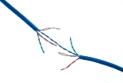
- Do not use electricity near water.

- Do not overload any one power outlet.
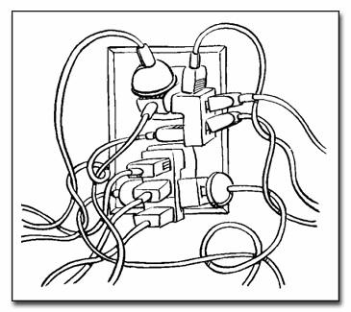
- Fuses and Circuit Breakers. Every electrical device in your home that is connected to a power supply is protected by a fuse somewhere along the circuit connecting it to electrical supply. The biggest fuses in your house are located in the fuse or circuit breaker panel. This is mounted on the wall where electrical power lines come inside your house and split into the circuits that run through your home. Without fuses, power surges from electric generators or short circuits within your house could burn out appliances, circuit boards and wiring. Any of these could lead to fires or further damage to the electrical systems within the building.
Fuses all contain a filament or strip made of metals. This filament melts and breaks when a certain current or "load" has been exceeded. It melts and breaks the circuit. This stops the current and prevents a fire. A new fuse must be used to re-establish the circuit. Depending on the circuit, different fuses will burn out(melt) at a specific current. Most household circuits carry 10, 15 or 20-amp. Fuse wires are one-time use. Once they burn out, they have to be replaced.
Circuit Breakers are like light switches. They do the same job as fuses but do not “burn out” when the current gets too high. When they overheat they switch off and lock. This "lock" (actually its more of a spring) causes the switch to shut off. You can flip the breaker to reset it, but generally if it’s too hot, it won’t stay on until it has cooled to a safe operating temperature.
- Make sure plugs and appliances have an earth wire. When a short circuit in the appliance occurs the earth wire allows the electricity to be safely conducted to the earth. This is better than the electric current running through you to the Earth.
- If in doubt use a qualified electrician.

